# **New National Biogas and Organic Manure Programme (NNBOMP) – 2020**

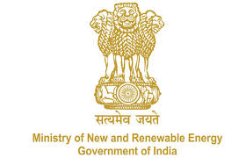

NNBOMP Information point (in case of doubts call us): 011-24360707; 24361920 Extn. 1047<https://mnre.gov.in/img/documents/uploads/dc65ef193ca9419f807441cfc193be3a.pdf>

**Inspector registration request form**

*Form number: P6.S1_d ver. 1 (2020.05.10)*

*Officials from BDTC, SNA, KVIC, NDDB, State Govt. Department & Financial Institutions can register as Inspector*

*This form is developed for registering the inspectors. The form should be sent to* [*biogas-mnre@gov.in*](mailto:biogas-mnre@gov.in)*. The sender can expect that the registration will be done in 48 hours. The information, together with the password will be sent together with the confirmation.*

I’m hereby registering myself as the Bio-Gas inspector to the bio-gas portal. I am aware that I would be able to inspect plants when the registration is confirmed by the appropriate agency.

I am also instructed, that the inspection process will be done using mobile application.

*Please enter the mobile phone number to be used during inspection - time to time text messages can be send to you by the system.*

|  |  |
| --- | --- |
| Name | Text |
| Date of birth | Date |
| State | Text |
| Phone number | Number |
| Email to contact | email |
| Name of biogas training attended | Text |
| Agency to be affiliated | Text |
| Designation in the organization | Text |
| Comment | Text |
| Photograph | attachment |

Date:

Sign